Criar Rota e Controller Para Usar na API

Atribuir skiPresenter True em CupomRepositoryEloquent

**protected $skipPresenter** = **true**;

Criando Cupom Controller

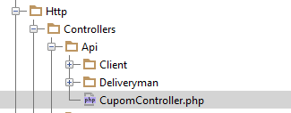

**<?php  
  
namespace** CodeDelivery\Http\Controllers\Api\Client;  
  
**use** CodeDelivery\Http\Controllers\Controller;  
**use** CodeDelivery\Http\Requests;  
**use** CodeDelivery\Repositories\CupomRepository;  
  
  
**class** CupomController **extends** Controller  
{  
  
 **private $cupomRepository**;  
  
 **public function** __construct(CupomRepository $cupomRepository)  
 {  
 $this->**cupomRepository** = $cupomRepository;  
 }  
  
 **public function** show($code)  
 {  
 **return** $this->**cupomRepository**->skipPresenter(**false**)->findByCode($code);  
 }  
  
}

Criar Rota

Route::*get*(**'cupom/{code}'**, **'Api\CupomController@show'**);